

Save a copy of this document somewhere you can access.

This is ***your*** learning journal. Make sure that you keep it updated as you progress through the Project. Your teacher will let you know when to complete each step. Document both your successes and your failings as they provide the most important learning opportunities!

To get started, please type your name in the following box:

|  |
| --- |
|  |

# Step 1: Define

After watching the video in the [Define](http://app.createbase.co.nz/project/send-it/define) step on the platform, your teacher will have a discussion with the class about what has happened. Afterwards, they may ask you to answer the following questions. When you are done, move on to the Imagine step.

1. List 5 things you can observe from the video**.** Remember, an observation is what you can see, not what you think is happening!

|  |
| --- |
|  |

1. Using your observations from the previous question, come up with two inferences about what is happening in the video.Remember, an inference is a short conclusion made based on evidence (observations).

|  |
| --- |
|  |

1. Based on your inference made in the previous question, what do you think is the main issue being described in the video?

|  |
| --- |
|  |

1. How do you think this situation could have been avoided? List 3 things.

|  |
| --- |
|  |

# Step 2: Imagine

As a group, select ONE of the first five Imagine modules at <https://app.createbase.co.nz/project/send-it/imagine> to complete. For reference, the names of these modules are:

* Vehicular Delivery
* Your Robot has Mail
* Controlling a Robot
* Sensing Sensors
* Automation & Ethics

Discuss all of your answers as a team, but make sure that every member writes a summary in their own learning journal in the box below. Bullet points and incomplete sentences are acceptable. If you finish early, your teacher may ask you to complete a second module as well.

|  |
| --- |
|  |

Once you have finished, check out the content in the orange How to Send It module, then press the green Give it a go button in the bottom left-hand corner of the platform to control the robot manually.

When manually controlling the robot, you should be thinking about three things at all times: what decisions am I making, what information am I using to make these decisions, and what actions am I performing based on my decisions.

Keep going until you have gained an understanding of the simulation as you will be working with it for the remainder of this Project (you aren’t expected to be able to complete it manually).

# Step 3: Create

## Subsystem 1

### Research

On the platform, navigate to the [Research](http://app.createbase.co.nz/project/send-it/create/Obstacle%20avoidance/research) step for the first subsystem. If you get stuck or confused, ask your classmates or a teacher.

You have two programming options available to you for completing this Project. You can either code using a visual programming language called **Flow**, or a text programming language called **JavaScript** (JS). Your teacher will let you know what language they want you to use. Otherwise, feel free to choose. You can always switch between the two at any time.

If you are going to create your solution using **JavaScript**, skip to the next set of questions.If you are going to create your solution using **Flow**, then watch the Flow: Editor tutorial video and read the Flow: Introduction to blocks document as well as the Flow: Tips & tricks with sensing blocks document on the platform. You will then be able to answer the following questions:

1. **Describe what a sensor is in your own words. What type of value do each of our sensors output?**

|  |
| --- |
|  |

1. **If the speed of the next obstacle is 3 and the distance to the next obstacle is 2, what would be the output of the following and block?**

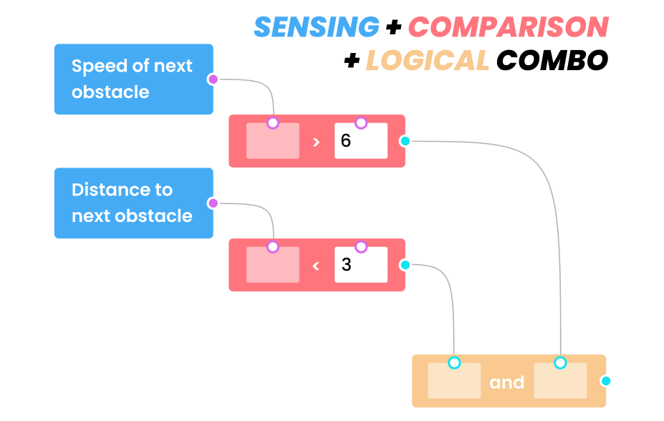

|  |
| --- |
|  |

1. **If the speed of the next obstacle is 7 and the distance to the next obstacle is 0, what would be the output of the following and block?**



|  |
| --- |
|  |

1. **In the following example, which action blocks will be run and in what order?**

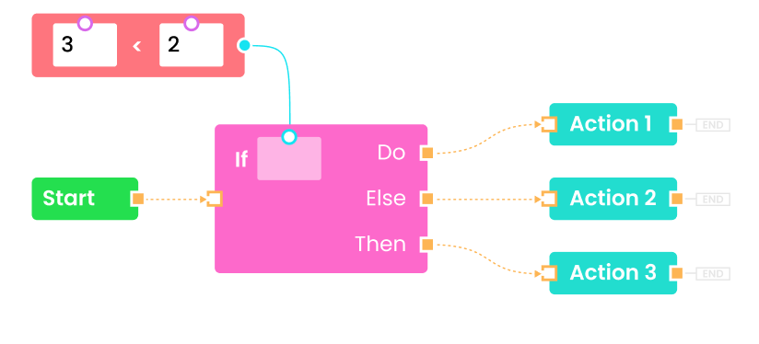

|  |
| --- |
|  |

If you are going to create your solution using **JavaScript**, then read the JS: Introduction to JavaScript document and the JS: Tips & tricks with sensing functions document on the platform. You will then be able to answer the following questions:

1. **Describe what a sensor is in your own words. What type of value do each of our sensors output?**

|  |
| --- |
|  |

1. **Describe what a function is in your own words.**

|  |
| --- |
|  |

1. **Describe what an IF ELSE statement is in your own words.**

|  |
| --- |
|  |

1. **If we have a code statement that we only want to run if variable1 is greater than Variable2 OR variable3 is equal to Variable4, what piece of JS code would we write?**

|  |
| --- |
|  |

When you have answered EITHER the Flow or JavaScript questions, check out the two mini-games in the green Explore more card while you wait for your classmates to catch up. These games will help you practice using comparison and if blocks.

When your teacher says you can move on, proceed to the Plan step for this subsystem.

### Plan

Your robot will be faced with many tough decisions as a self-driving vehicle. Type your answer to these brief questions in the boxes below to explain what you think your robot should do in these situations:

1. When you were manually controlling the robot, you were using your human sensors to read information and then use that information to make a decision to perform an action.
   1. Every milli-second, you were making a decision: “do I perform action X now or wait?” What action were you performing?

|  |
| --- |
|  |

* 1. What information were *you* using to make this decision? (how did you know when to perform action X?)

|  |
| --- |
|  |

* 1. What “human sensor” were you using to gather this information?

|  |
| --- |
|  |

1. If your robot has to choose between hitting an unmanned drone or a family car what should it hit? Explain your reasoning.

|  |
| --- |
|  |

1. If your robot is going to crash into a family car containing four people, should it self-destruct instead? Explain your reasoning.

|  |
| --- |
|  |

1. How would your answer change if there was one pedestrian standing nearby that would be caught in the explosion? Should your robot self-destruct to avoid the family car but harm the pedestrian? Explain your reasoning.

|  |
| --- |
|  |

1. How would your answer change if instead there were four pedestrians standing nearby that would be caught in the explosion? Explain your reasoning.

|  |
| --- |
|  |

### Code

You can now return to the platform and create your answer as part of the Code step. Make sure that you refer back to the Research and Plan content in your learning journal or the platform whenever you get stuck!

When you have finished with Code, add a screenshot of your final solution below showing the success screen as well as either the Flow or text code. Then, write a brief explanation of how it works, including any problems that you encountered along the way and how you overcame them.

**Important**: *you can save your Flow code using the save icon () in the toolbar in the bottom left corner of the Flow editor. If you save your code before you leave the simulation, you will be able to continue where you left off when you return by pressing the restore icon directly below the save icon.*

*You can save your JavaScript code using the* SAVE *button in the bottom right corner of the text editor. If you save your code before you leave the simulation, you will be able to continue where you left off when you return by pressing the* RESTORE *button.*

|  |
| --- |
|  |

# Step 4: Improve

Add comments and a screenshot of your final Improve solution below. You may also want to provide multiple screenshots throughout your development to highlight how your solution improved over time::

|  |
| --- |
|  |

# Step 5: Review

Congratulations on completing the Project! Please type your answers to the following questions:

1. If you had more time available, how could you potentially improve your solution? If your solution to the Create step didn’t work, try and explain why.

|  |
| --- |
|  |

1. Think about what you achieved during the project. What are you most proud of?

|  |
| --- |
|  |

1. Think about the parts of the project that didn’t go well. List up to **three** of them below. If nothing went bad, think about things that you could have done better.

|  |
| --- |
|  |

1. Choose **one** from question 4. Why do you think it didn’t go well? If you were going to redo this Project, what would you do differently to avoid this negative?

|  |
| --- |
|  |